**Experiment No 5**

**Name : Mohammad Sohail Shaikh A56**

**Code: Write a program to find Number is prime or not.**

def is_prime(n):

"""

Checks if a number is prime.

:param n: Integer to check

:return: True if prime, otherwise False

"""

if n < 2:

return False # Prime numbers start from 2

for i in range(2, int(n ** 0.5) + 1): # Check divisibility up to sqrt(n)

if n % i == 0:

return False # If divisible, not a prime

return True # If no divisors found, it's prime

# Get user input

num = int(input("Enter a number to check if it's prime: "))

# Check and print the result

if is_prime(num):

print(f"{num} is a prime number.")

else:

print(f"{num} is NOT a prime number.")

**Output:  
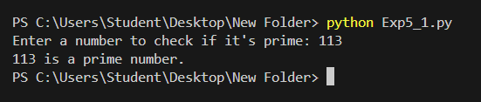**

**Code: Sum of all Natural number from 1 to n.**

def sum_natural(n):

"""

Recursively calculates the sum of the first n natural numbers.

:param n: The number up to which the sum is calculated

:return: Sum of natural numbers from 1 to n

"""

if n <= 0:

return 0 # Base case: Sum of 0 natural numbers is 0

return n + sum_natural(n - 1) # Recursive case: n + sum of (n-1)

# Get user input

num = int(input("Enter a number: "))

# Check for valid input

if num < 0:

print("Please enter a positive integer.")

else:

result = sum_natural(num)

print(f"Sum of first {num} natural numbers is: {result}")

**Output:  
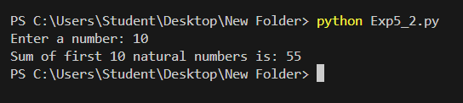**

**Code: Filter out prime numbers.**

# Function to check if a number is prime

is_prime = lambda n: n > 1 and all(n % i != 0 for i in range(2, int(n ** 0.5) + 1))

# Example list

num_list = [10, 15, 17, 19, 21, 23, 30, 31, 35, 37]

# Filter out prime numbers

filtered_list = list(filter(lambda x: not is_prime(x), num_list))

# Print the result

print("List after filtering out prime numbers:", filtered_list)

**Output:**

